Task 2 : Network Security & Scanning Report
1. Objective
The objective of this lab is to perform:
- Network scanning using Nmap
- Vulnerability assessment using OpenVAS
- Packet analysis using Wireshark
All scans were conducted in a controlled lab environment using Kali Linux and Metasploitable2.
2. Lab Environment
- Attacker Machine: Kali Linux
- Target Machine: Metasploitable2
- Network Type: Host-only / Internal
- Target IP Address: 192.168.56.101
Nmap Scan Report
3. Tool Used
Nmap (Network Mapper)
4. Scan Command Executed
nmap -sS -sV -O 192.168.56.101
5. Scan Explanation
- -sS (TCP SYN Scan):
Performs a stealthy scan to identify open TCP ports.
- -sV (Service Version Detection):
Identifies the service and version running on each open port.
- -O (OS Detection):
Attempts to determine the operating system of the target.
- -oN:
Saves the scan output in a text file.
6. Nmap Scan Result
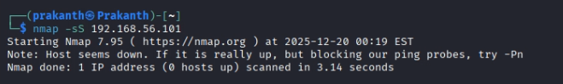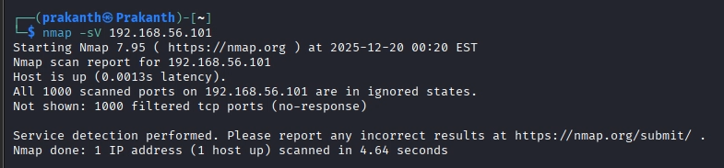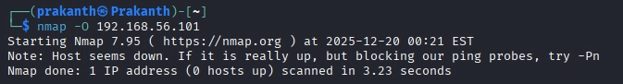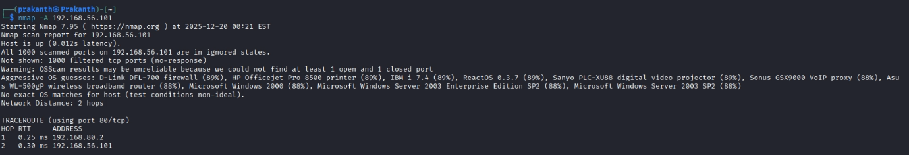
7. Nmap Scan Conclusion
The Nmap scan revealed a large attack surface due to multiple open ports and outdated services. This information can be used for further vulnerability analysis.
OpenVAS Vulnerability Scan Report
8. Tool Used
OpenVAS (Greenbone Vulnerability Manager)
9. Scan Procedure
- OpenVAS Web UI accessed at:
- https://127.0.0.1:9392
- Target created using Metasploitable2 IP address
- Scan configuration selected: Full and Fast
- Scan task started and allowed to complete
10. OpenVAS Expected
After completion of the scan, OpenVAS generated a vulnerability report containing:
- List of detected vulnerabilities
- Affected services and ports
- CVE identifiers
- Risk severity
- Suggested remediation steps
Since Metasploitable2 is intentionally vulnerable, a high number of issues were detected.
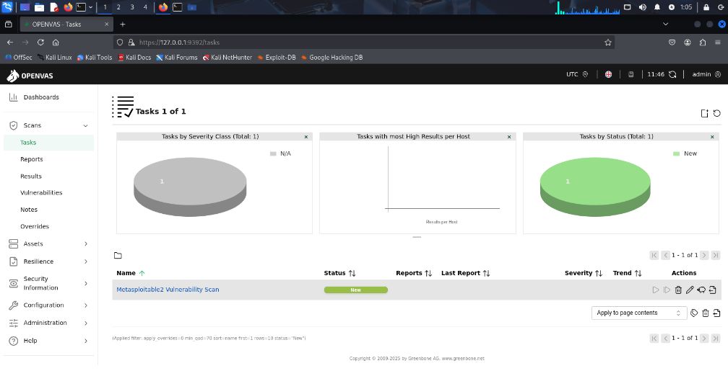
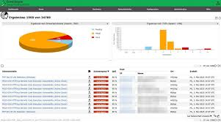
11. Severity Categories (OpenVAS)
OpenVAS classifies vulnerabilities into the following categories:
- Critical:
Vulnerabilities that allow immediate exploitation and system compromise.
- High:
Serious vulnerabilities that can lead to unauthorized access or data leakage.
- Medium:
Vulnerabilities with moderate risk that require specific conditions to exploit.
- Low:
Minor issues or misconfigurations with limited impact.
- Log / Informational:
Informational findings with no direct security risk.
12. OpenVAS Scan Conclusion
The OpenVAS scan confirmed that the target system is highly vulnerable.
Multiple critical and high-risk vulnerabilities were identified, highlighting the importance of regular vulnerability scanning and secure system configuration.
Wireshark Packet Analysis Report
13. Tool Used
Wireshark
14. Packet Capture Procedure
- Wireshark launched with root privileges
- Network interface selected
- Live traffic capture started
- Filters applied to analyze specific protocols
15. Filters Applied and Analysis
HTTP Traffic Filter
http
- Used to analyze unencrypted web traffic
- HTTP requests and responses were visible in plain text
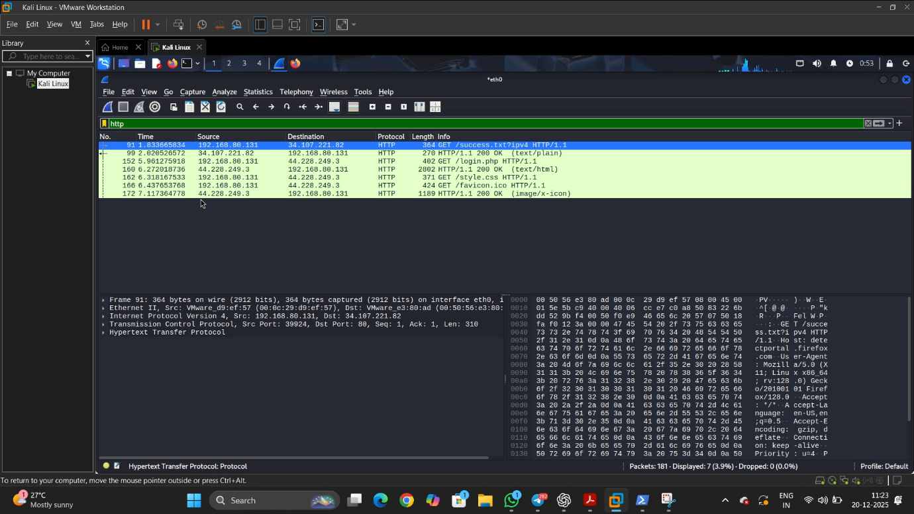
- Wireshark showing HTTP packets

UDP Traffic Filter
udp
- Used to observe DNS and other UDP-based communication
- Packet source and destination details were visible
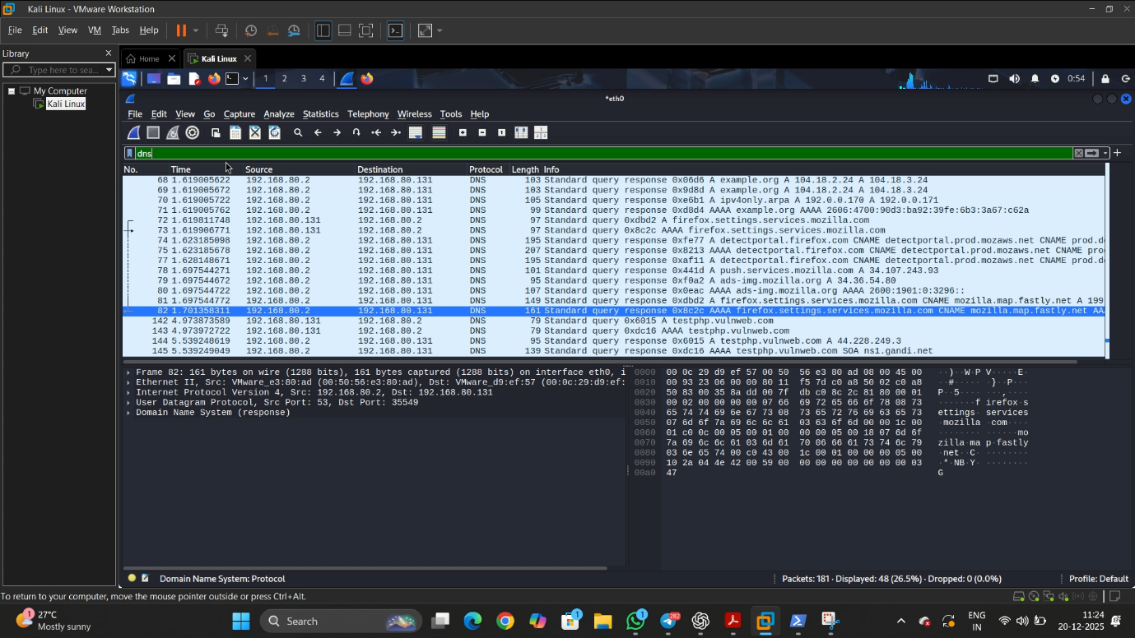
- Wireshark showing UDP packets
FTP Traffic Filter
ftp
- Used to analyze FTP communication
- FTP credentials can be transmitted in plain text
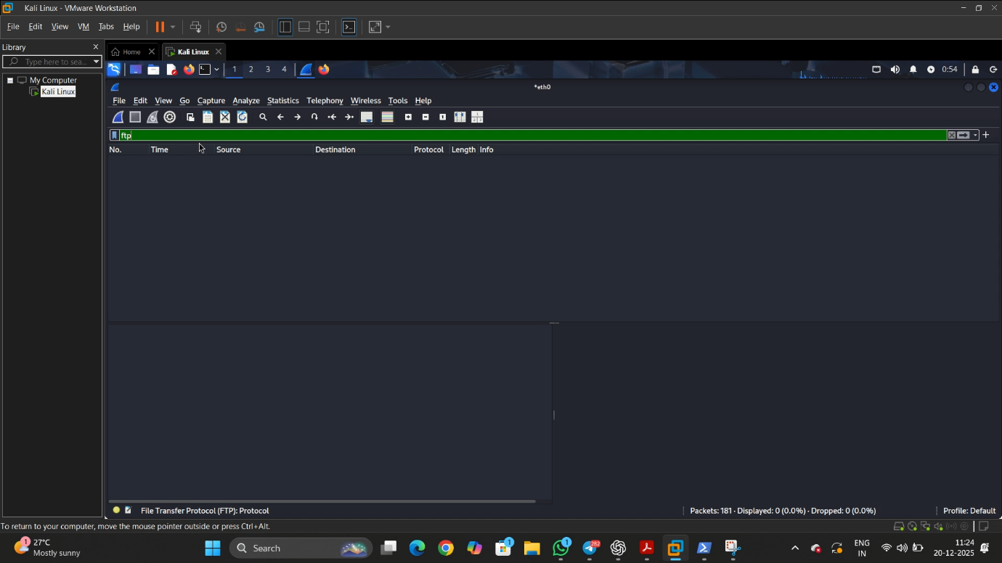
- Wireshark showing FTP packets (USER / PASS commands if available)
TCP SYN Packet Traffic Filter
tcp.flags.syn == 1 && tcp.flags.ack == 0
- Used to analyze TCP connection initiation packets generated during scanning activity.
- TCP SYN packets indicate the first step of the TCP three-way handshake and are commonly observed during port scanning and reconnaissance.
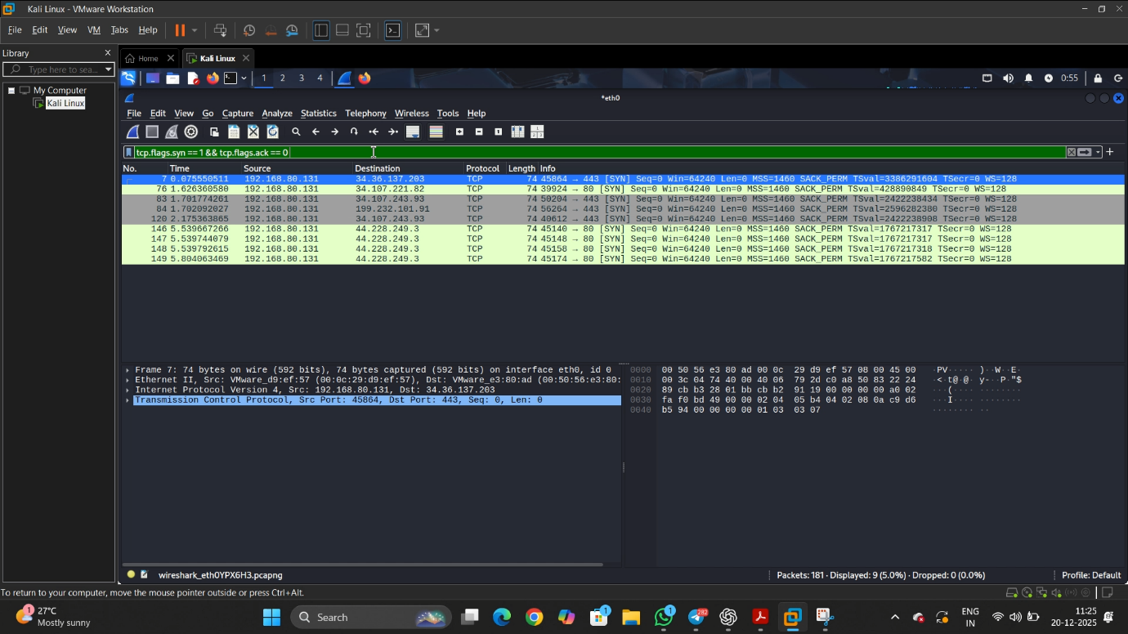
- Wireshark showing multiple TCP SYN packets captured on interface eth0, with the SYN flag set and ACK flag unset, indicating active connection attempts to ports such as 80 (HTTP) and 443 (HTTPS).
16. Wireshark Analysis Conclusion
Wireshark analysis demonstrated how unencrypted protocols expose sensitive information on the network. This highlights the importance of using secure protocols such as HTTPS and SFTP.
Final Conclusion
This lab successfully demonstrated:
- Port and service discovery using Nmap
- Vulnerability assessment using OpenVAS
- Network traffic analysis using Wireshark
The results emphasize the importance of network monitoring, vulnerability scanning, and secure communication practices.

